**Maximize Score**

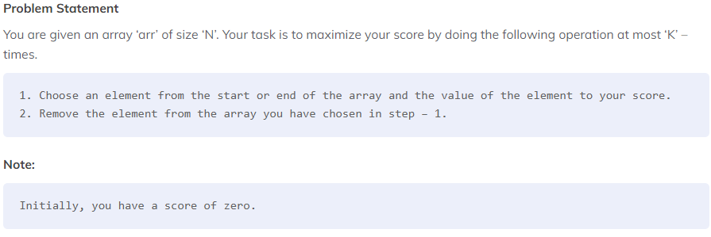

##### ***Sample Input 1:***

***2***

***5 1***

***10 2 8 9 2***

***5 2***

***10 5 6 7 9***

##### ***Sample Output 1:***

***10***

***19***

##### ***Explanation Of Sample Input 1:***

***Test Case 1 :***

***Given N = 5 and K = 1.***

***arr = [10, 2, 8, 9, 2]***

***Initial score = 0***

***In the first operation choose 10 from the start and add it to the score.***

***So final score = 10.***

***Test Case 2 :***

***Given N = 5 and K = 2.***

***arr = [10, 5, 6, 7, 9]***

***Initial score = 0***

***In the first operation choose 10 from the start and add it to the score.***

***So score = 10 and arr = [5, 6, 7, 9]***

***In the second operation choose 9 from the end and add it to the score.***

***So final score = 10 + 9 = 19.***

##### ***Sample Input 2:***

***2***

***4 4***

***10 2 2 2***

***4 3***

***10 1 7 9***

##### ***Sample Output 2:***

***16***

***26***

##### ***Explanation Of Sample Input 2:***

***Test Case 1 :***

***Given N = 4 and K = 4.***

***arr = [10, 2, 2, 2]***

***Initial score = 0***

***Here N = K. So we can add all elements to our score by always picking array elements from the start.***

***So final score = 10 + 2 + 2 + 2 = 16.***

***Test Case 2 :***

***Given N = 4 and K = 3.***

***arr = [10, 1, 7, 9]***

***Initial score = 0***

***In the first operation choose 10 from the start and add it to the score.***

***So score = 10 and arr = [1, 7, 9]***

***In the second operation choose 9 from the end and add it to the score.***

***So score = 10 + 9 = 19 and and arr = [1, 7]***

***In the third operation choose 7 from the end and add it to the score.***

***So final score = 19 + 7 = 26.***